Useful websites to note:

* About IBM Blockchain Platform

IBM Blockchain Platform Console Video Series

<https://developer.ibm.com/series/ibm-blockchain-platform-console-video-series/?cm_mmc=OSocial_Blog-_-Developer_IBM+Developer-_-WW_WW-_-ibmdev-OInfluencer-YouTube-KA-blockchain-series&cm_mmca1=000037FD&cm_mmca2=10010797>

Getting started with IBM Blockchain Platform

<https://cloud.ibm.com/docs/blockchain>

Deploy a smart contract using Fabric v2.x

<https://cloud.ibm.com/docs/blockchain?topic=blockchain-ibp-console-smart-contracts-v2>

Developing smart contracts with IBM Blockchain Platform Developer Tools

<https://cloud.ibm.com/docs/blockchain?topic=blockchain-develop-vscode#develop-vscode-install>

* About Visual Studio, read First Steps

<https://code.visualstudio.com/docs/?dv=win64user>

<https://code.visualstudio.com/docs/typescript/typescript-compiling>

IBM-Blockchain/blockchain-vscode-extension

<https://github.com/IBM-Blockchain/blockchain-vscode-extension>

WHAT IS DOCKER?

It is a Container.

Watch the most popular videos from DockerCon.

How to get started with Docker

<https://www.youtube.com/watch?v=iqqDU2crIEQ&t=30s>

How to build and test your Docker images in the Cloud

<https://www.youtube.com/watch?v=xmLVNpyJ530&t=30s>

Simplify all the things with Docker Compose

<https://www.youtube.com/watch?v=QeQ2MH5f_BE&t=31s>

Broad steps of IBM Blockchain

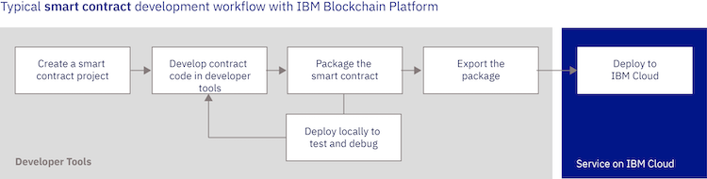

Taken from: a2.pdf. BC_Proj/src/my-asset-contract.ts

|  |  |
| --- | --- |
| /*   * SPDX-License-Identifier: Apache-2.0   */  import { Context, Contract, Info, Returns, Transaction } from 'fabric-contract-api';  import { MyAsset } from './my-asset';  @Info({title: 'MyAssetContract', description: 'My Smart Contract' })  export class MyAssetContract extends Contract {      @Transaction(false)      @Returns('boolean')      public async myAssetExists(ctx: Context, myAssetId: string): Promise<boolean> {          const data: Uint8Array = await ctx.stub.getState(myAssetId);          return (!!data && data.length > 0);  }      @Transaction()      public async createMyAsset(ctx: Context, myAssetId: string, value: string): Promise<void> {          const exists: boolean = await this.myAssetExists(ctx, myAssetId);          if (exists) {              throw new Error(`The my asset ${myAssetId} already exists`);          }          const myAsset: MyAsset = new MyAsset();          myAsset.value = value;          const buffer: Buffer = Buffer.from(JSON.stringify(myAsset));          await ctx.stub.putState(myAssetId, buffer);      }      @Transaction(false)      @Returns('MyAsset')      public async readMyAsset(ctx: Context, myAssetId: string): Promise<MyAsset> {          const exists: boolean = await this.myAssetExists(ctx, myAssetId);          if (!exists) {              throw new Error(`The my asset ${myAssetId} does not exist`);          }          const data: Uint8Array = await ctx.stub.getState(myAssetId);          const myAsset: MyAsset = JSON.parse(data.toString()) as MyAsset;          return myAsset;      }      @Transaction()      public async updateMyAsset(ctx: Context, myAssetId: string, newValue: string): Promise<void> {          const exists: boolean = await this.myAssetExists(ctx, myAssetId);          if (!exists) {              throw new Error(`The my asset ${myAssetId} does not exist`);          }          const myAsset: MyAsset = new MyAsset();          myAsset.value = newValue;          const buffer: Buffer = Buffer.from(JSON.stringify(myAsset));          await ctx.stub.putState(myAssetId, buffer);      }      @Transaction()      public async deleteMyAsset(ctx: Context, myAssetId: string): Promise<void> {          const exists: boolean = await this.myAssetExists(ctx, myAssetId);          if (!exists) {              throw new Error(`The my asset ${myAssetId} does not exist`);          }          await ctx.stub.deleteState(myAssetId);      }  } |  |

In A3, created 3 different Local Networks (1 Org Local Fabric, 1OrgLo and 2by2) using the preconfigured *one organization network* that comes together with the IBM VC extension code.

|  |  |  |
| --- | --- | --- |
| (1) Running 2by2. | (2) Exited 2by2, and connected to 1 OrgLo, note that the view has changed. | (3) Expand all arrows under Fabric Wallets to see the full contents |
|  |  |  |
| Note:  - 1 Org Local Fabric (as per the tutorial) and 1 OrgLo environments are created from 1 Org template, with 1 CA, 2 peers, 1 channel..  - 2by2 environment is created from 2 Org template, with 2 CAs, 2 peers, 1 channel. This template was not available the day before.  - See (2), *Simple local networks* is gone which means you cannot create a new network after you entered one. You will need to click exit (🡨) to go back to the previous screen with *Simple local networks*. Also, the 2by2 has 2 Wallets, namely Org1 and Org2, as 2by2 has 2 peers.  - See (3), after expanded the arrows fully. Org1 and Org2 wallets each has one Identity, namely Org1 Admin and Org2 Admin identities. Take note of the difference in icon for wallets, identity and environment etc… | | |

|  |  |
| --- | --- |
|  |  |
| Smart Contract for 1 OrgLo deploying | Note the contract name after deployment |

a4.pdf

For good sake, after days of troubleshooting on why the five transaction methods finally appeared. It should stated clearly to park the files/folders strictly following the tutorial: demo-contract @ desktop. KNN!

|  |  |
| --- | --- |
|  | This was the error that kept showing.  [25/04/2021 9:33:37 am] [WARNING] Could not get metadata for smart contract demo-contract. The smart contract may not have been developed with the programming model delivered in Hyperledger Fabric v1.4+ for Java, JavaScript and TypeScript. Error: Transaction function "org.hyperledger.fabric:GetMetadata" returned an error: Query failed. Errors: ["Peer org1peer-api.127-0-0-1.nip.io:8084: error in simulation: failed to execute transaction 990edd961567af93ef64408ac8feee8f789f92e0086631efa225215c83ae629d: could not launch chaincode demo-contract_0.0.1:6da187e384f13aa34360d36f2c645a793b7d811c32d4ae7b483d8519f312fa87: chaincode registration failed: failed to wait on container exit: builder 'node' run failed: exit status 1"]  [12/07/2021 5:54:59 pm] [WARNING] Could not get metadata for smart contract crowdfund. The smart contract may not have been developed with the programming model delivered in Hyperledger Fabric v1.4+ for Java, JavaScript and TypeScript. Error: Transaction function "org.hyperledger.fabric:GetMetadata" returned an error: Query failed. Errors: ["Peer org2peer-api.127-0-0-1.nip.io:8087: error in simulation: failed to execute transaction f06a72095e86847a8bfcd08af0086387e2a05c90fd912ecf307dcd92c510c08a: could not launch chaincode crowdfund_0.0.1:0f3f09b86003b69c5211b817943c513750ac900a8cef14103b954ce949c1d3f2: chaincode registration failed: failed to wait on container exit: builder 'node' run failed: exit status 1","Peer org1peer-api.127-0-0-1.nip.io:8087: error in simulation: failed to execute transaction f06a72095e86847a8bfcd08af0086387e2a05c90fd912ecf307dcd92c510c08a: could not launch chaincode crowdfund_0.0.1:0f3f09b86003b69c5211b817943c513750ac900a8cef14103b954ce949c1d3f2: chaincode registration failed: failed to wait on container exit: builder 'node' run failed: exit status 1"] |
|  |  |

The following MyAssets are created. Even if you created (and have them deleted), it will be there (unless deleted in earlier sessions) the data (MyAssets) will still be there.

001 – Mona Lisa

002 – Lisa 2

003 – Lisa 3

004 – 004 asiL (caa 2 May, using updateMyAsset), previously Lisa 4 (caa 26 Apr)

005 to 009 – did not create

010 to 011 – created and deleted on 26 Apr

**2 May 2021**

Started up VS Code. Click on [1 Org Local Fabric (click to start)] under Fabric Environment. It failed.

*[ERROR] Failed to start 1 Org local fabric: Error: Environment failed to become available. Please check the Docker container logs for more details.*

Suspect it is due to I turned off Docker at start up. Second run - turned back on Docker at Settings during start up also did not work. Third run - then I ran Docker Desktop. It worked. This was run on Desktop folder.

Turning off Docker at Start up at Settings. Closed Docker Desktop. It is still running.

Conclusion: Run Docker Desktop first.

|  |  |
| --- | --- |
| First run -failed | Third run - succeed |
| [02/05/2021 9:57:30 am] [INFO] connecting to fabric environment  [02/05/2021 9:57:31 am] [INFO] startFabricRuntime  [02/05/2021 9:57:31 am] [INFO] C:\Users\timma\.fabric-vscode\v2\environments\1 Org local fabric>rem  [02/05/2021 9:57:31 am] [INFO] C:\Users\timma\.fabric-vscode\v2\environments\1 Org local fabric>rem Copyright IBM Corp All Rights Reserved  [02/05/2021 9:57:31 am] [INFO] C:\Users\timma\.fabric-vscode\v2\environments\1 Org local fabric>rem  [02/05/2021 9:57:31 am] [INFO] C:\Users\timma\.fabric-vscode\v2\environments\1 Org local fabric>rem SPDX-License-Identifier: Apache-2.0  [02/05/2021 9:57:31 am] [INFO] C:\Users\timma\.fabric-vscode\v2\environments\1 Org local fabric>rem  [02/05/2021 9:57:31 am] [INFO] C:\Users\timma\.fabric-vscode\v2\environments\1 Org local fabric>setlocal enabledelayedexpansion  [02/05/2021 9:57:31 am] [INFO] C:\Users\timma\.fabric-vscode\v2\environments\1 Org local fabric>SET CUSTOM_IMAGE=  [02/05/2021 9:57:31 am] [INFO] C:\Users\timma\.fabric-vscode\v2\environments\1 Org local fabric>if DEFINED CUSTOM_IMAGE (  [02/05/2021 9:57:31 am] [INFO] SET START_IMAGE= ) ELSE (SET START_IMAGE="ibmcom/ibp-microfab:0.0.11" )  [02/05/2021 9:57:31 am] [INFO] C:\Users\timma\.fabric-vscode\v2\environments\1 Org local fabric>echo "Using image: "ibmcom/ibp-microfab:0.0.11""  [02/05/2021 9:57:31 am] [INFO] "Using image: "ibmcom/ibp-microfab:0.0.11""  [02/05/2021 9:57:31 am] [INFO] C:\Users\timma\.fabric-vscode\v2\environments\1 Org local fabric>FOR /F "usebackq tokens=*" %g IN (`docker ps -f label=fabric-environment-name="1 Org local fabric Microfab" -q -a`) do (SET CONTAINER=%g )  [02/05/2021 9:57:32 am] [INFO] error during connect: This error may indicate that the docker daemon is not running.: Get http://%2F%2F.%2Fpipe%2Fdocker_engine/v1.24/containers/json?all=1&filters=%7B%22label%22%3A%7B%22fabric-environment-name%3D1+Org+local+fabric+Microfab%22%3Atrue%7D%7D: open //./pipe/docker_engine: The system cannot find the file specified.  [02/05/2021 9:57:32 am] [INFO] C:\Users\timma\.fabric-vscode\v2\environments\1 Org local fabric>IF DEFINED CONTAINER (  [02/05/2021 9:57:32 am] [INFO] docker  [02/05/2021 9:57:32 am] [INFO] start  [02/05/2021 9:57:32 am] [INFO] if !errorlevel! NEQ 0 (exit /b !errorlevel! )  [02/05/2021 9:57:32 am] [INFO] ) ELSE (  [02/05/2021 9:57:32 am] [INFO] SET MICROFAB_CONFIG={"port":8084, "endorsing_organizations": [{"name": "Org1"}],"channels": [{"name": "mychannel","endorsing_organizations": ["Org1"]}]}  [02/05/2021 9:57:32 am] [INFO] docker run -e MICROFAB_CONFIG --label fabric-environment-name="1 Org local fabric Microfab" -d -p 8084:8084 "ibmcom/ibp-microfab:0.0.11"  [02/05/2021 9:57:32 am] [INFO] )  [02/05/2021 9:57:33 am] [INFO] docker: error during connect: This error may indicate that the docker daemon is not running.: Post http://%2F%2F.%2Fpipe%2Fdocker_engine/v1.24/containers/create: open //./pipe/docker_engine: The system cannot find the file specified.  [02/05/2021 9:57:33 am] [INFO] See 'docker run --help'.  [02/05/2021 9:57:33 am] [INFO] C:\Users\timma\.fabric-vscode\v2\environments\1 Org local fabric>exit /b 0  [02/05/2021 9:58:18 am] [ERROR] Failed to start 1 Org local fabric: Error: Environment failed to become available. Please check the Docker container logs for more details. | [02/05/2021 10:11:29 am] [INFO] connecting to fabric environment  [02/05/2021 10:11:31 am] [INFO] startFabricRuntime  [02/05/2021 10:11:31 am] [INFO] C:\Users\timma\.fabric-vscode\v2\environments\1 Org local fabric>  [02/05/2021 10:11:31 am] [INFO] rem  [02/05/2021 10:11:31 am] [INFO] C:\Users\timma\.fabric-vscode\v2\environments\1 Org local fabric>rem Copyright IBM Corp All Rights Reserved  [02/05/2021 10:11:31 am] [INFO] C:\Users\timma\.fabric-vscode\v2\environments\1 Org local fabric>rem  [02/05/2021 10:11:31 am] [INFO] C:\Users\timma\.fabric-vscode\v2\environments\1 Org local fabric>rem SPDX-License-Identifier: Apache-2.0  [02/05/2021 10:11:31 am] [INFO] C:\Users\timma\.fabric-vscode\v2\environments\1 Org local fabric>rem  [02/05/2021 10:11:31 am] [INFO] C:\Users\timma\.fabric-vscode\v2\environments\1 Org local fabric>setlocal enabledelayedexpansion  [02/05/2021 10:11:31 am] [INFO] C:\Users\timma\.fabric-vscode\v2\environments\1 Org local fabric>SET CUSTOM_IMAGE=  [02/05/2021 10:11:31 am] [INFO] C:\Users\timma\.fabric-vscode\v2\environments\1 Org local fabric>if DEFINED CUSTOM_IMAGE  [02/05/2021 10:11:31 am] [INFO] (SET START_IMAGE= ) ELSE (SET START_IMAGE="ibmcom/ibp-microfab:0.0.11" )  [02/05/2021 10:11:31 am] [INFO] C:\Users\timma\.fabric-vscode\v2\environments\1 Org local fabric>echo "Using image: "ibmcom/ibp-microfab:0.0.11""  [02/05/2021 10:11:31 am] [INFO] "Using image: "ibmcom/ibp-microfab:0.0.11""  [02/05/2021 10:11:31 am] [INFO] C:\Users\timma\.fabric-vscode\v2\environments\1 Org local fabric>FOR /F "usebackq tokens=*"  [02/05/2021 10:11:31 am] [INFO] %g IN (`docker ps -f label=fabric-environment-name="1 Org local fabric Microfab" -q -a`) do (SET CONTAINER=%g )  [02/05/2021 10:11:32 am] [INFO] C:\Users\timma\.fabric-vscode\v2\environments\1 Org local fabric>(SET CONTAINER=d124be2ca55d )  [02/05/2021 10:11:32 am] [INFO] C:\Users\timma\.fabric-vscode\v2\environments\1 Org local fabric>IF DEFINED CONTAINER (  [02/05/2021 10:11:32 am] [INFO] docker start d124be2ca55d  [02/05/2021 10:11:32 am] [INFO] if !errorlevel! NEQ 0 (exit /b !errorlevel! )  [02/05/2021 10:11:32 am] [INFO] ) ELSE (  [02/05/2021 10:11:32 am] [INFO] SET MICROFAB_CONFIG={"port":8084, "endorsing_organizations": [{"name": "Org1"}],"channels": [{"name": "mychannel","endorsing_organizations": ["Org1"]}]}  [02/05/2021 10:11:32 am] [INFO] docker run -e MICROFAB_CONFIG --label fabric-environment-name="1 Org local fabric Microfab" -d -p 8084:8084 "ibmcom/ibp-microfab:0.0.11"  [02/05/2021 10:11:32 am] [INFO] )  [02/05/2021 10:11:34 am] [INFO] d124be2ca55d  [02/05/2021 10:11:34 am] [INFO] C:\Users\timma\.fabric-vscode\v2\environments\1 Org local fabric>exit /b 0  [02/05/2021 10:11:52 am] [SUCCESS] Connected to 1 Org local fabric |

**A5**.

In this file: tsconfig.json, the 3 lines are added at the top on 2 May 2021, 1120hrs. This is for troubleshooting why the first attempt using the folder created on D drive did not work.

/*

* this is from Desktop folder

*/

T.b.c after lunch

**Redoing… after moving renaming folders and around them around.** I want to know why this does not work in the early attempts. At that point of time, I did not install Docker Desktop, only the Docker extension in VS Code.

*D:\TKH\4. Course\IBM-CS Track\00. IBM Free Courses\00.2. IBM Blockchain Foundation Developer\BC_Proj (old folder, does not exist anymore)*

**A2.**

Difference I done.

* MyAsset is called OurAsset. Now I know what is the downstream changes to the scripts.
* Use another folder name, plus not from Desktop, *BC_proj* instead of *demo-contract*.

*D:\TKH\4. Course\4.00. IBM Free Courses\00.2. IBM Blockchain Foundation Developer\BC_Proj*

Instead of calling MyAsset like in the notes, I called it OurAsset. Note what have followed with this changed.

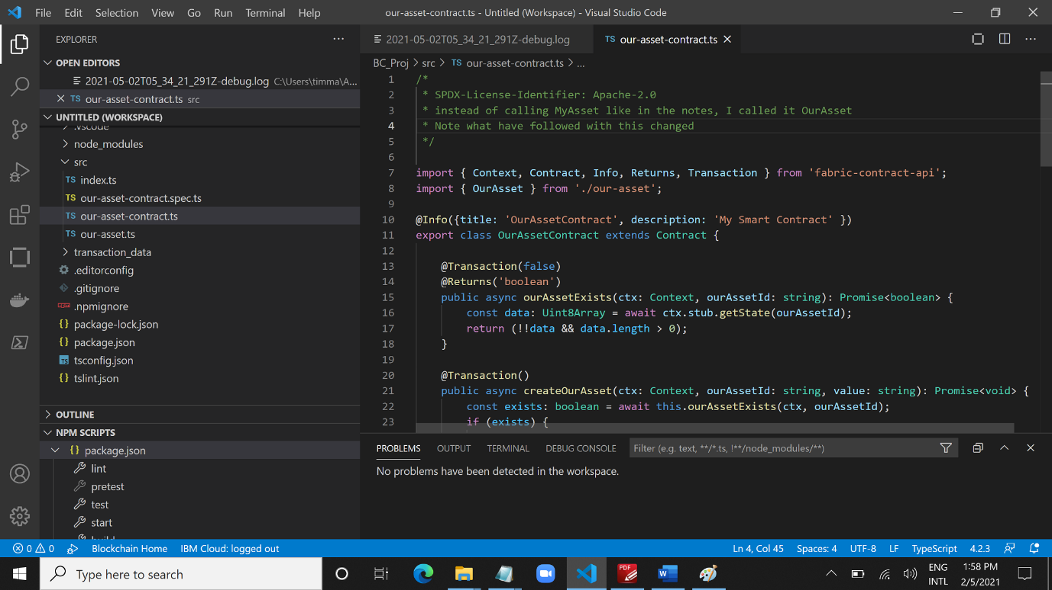

It showed this error.

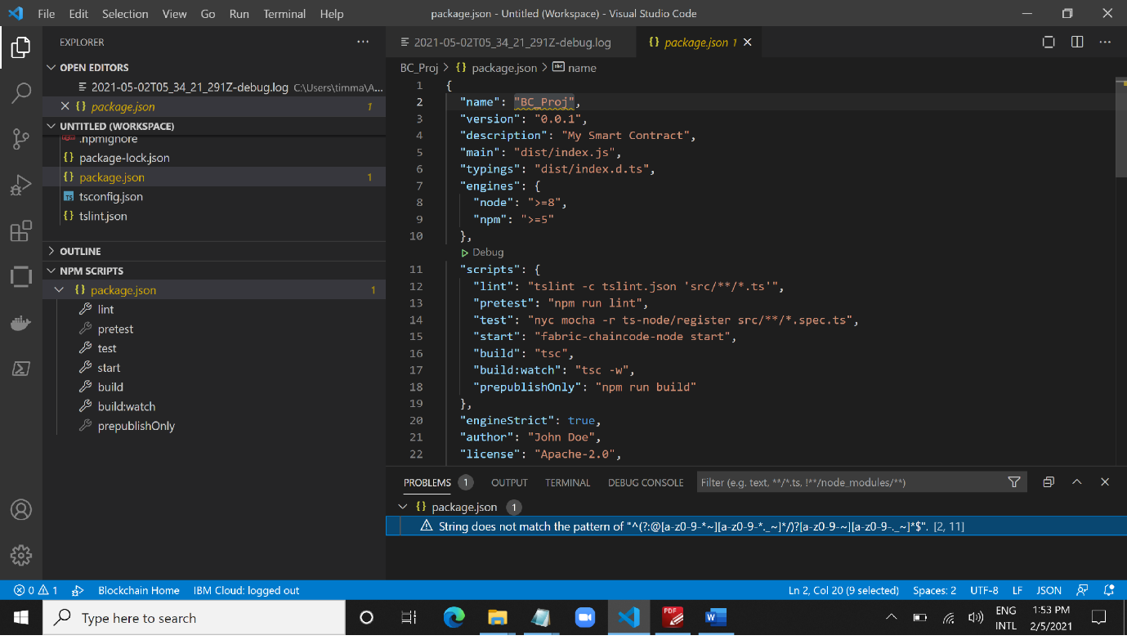

Let’s continue.

**A3.**

I did not call it "*1 Org Local Fabric*" environment as per the notes. I called it *1 ORG*.

As of now, looking good as what is supposed to have.

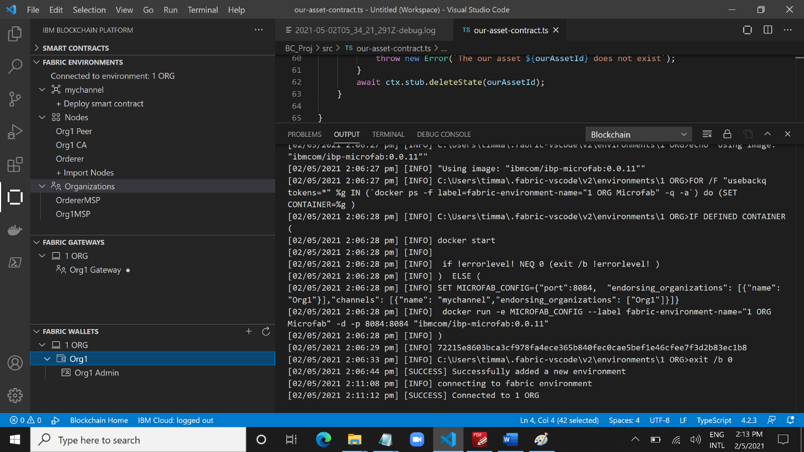

Packaged and deployed smart contract successfully.

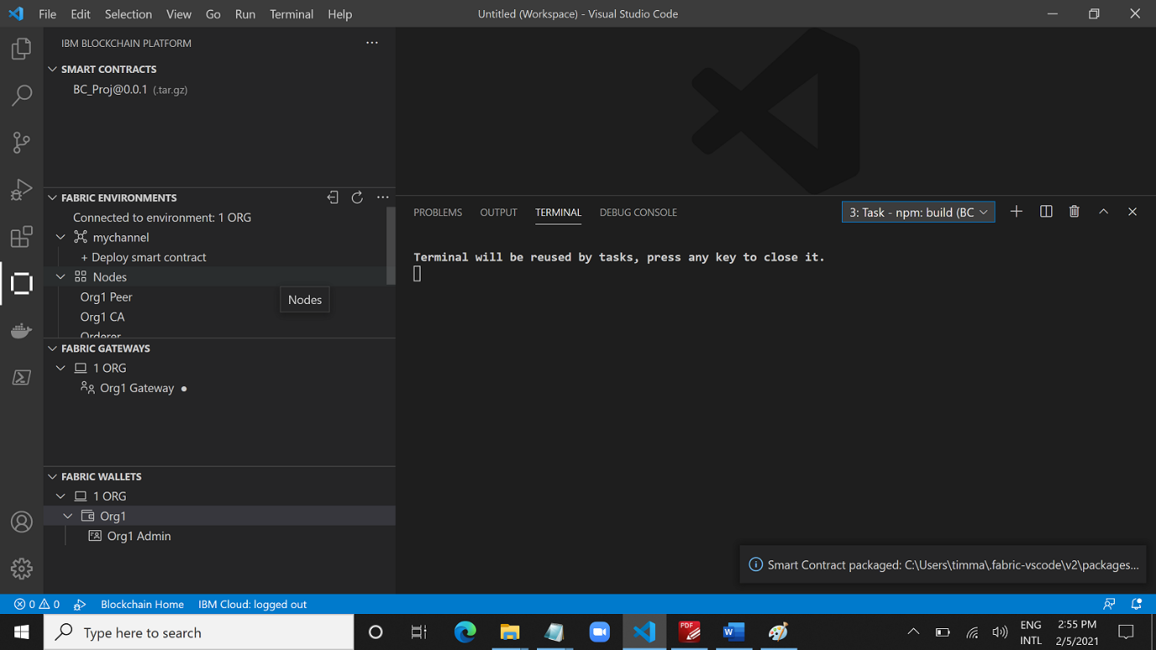

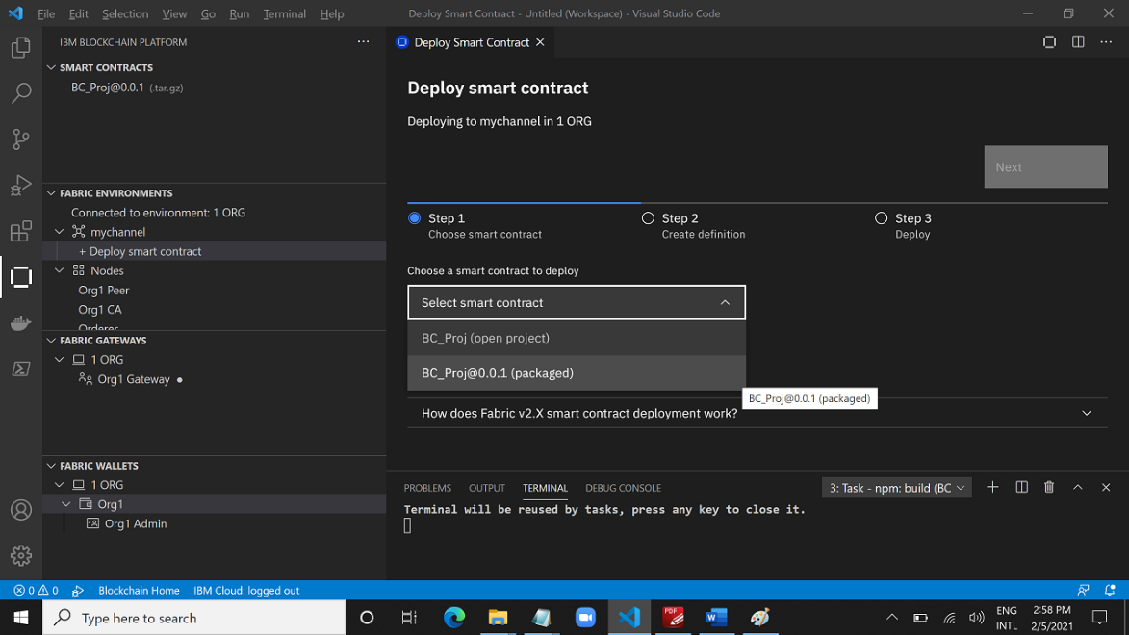

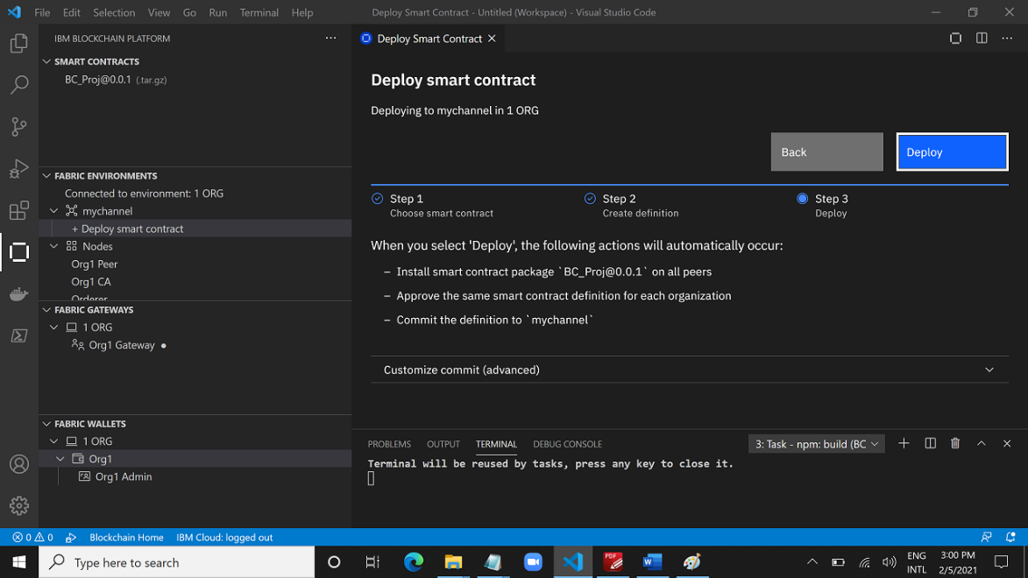

These immediately output where I click on Deploy. Refer to <Log - Deploy 1 ORG Smart Contract.txt> under <…\00.2. IBM Blockchain Foundation Developer\basic-tutorials> all looks good.

**A4.**

GOD!!!!!!

Now works, even with so many deviations from the notes!

1. Does not need to park at Desktop
2. Does not need to be called demo-contract folder
3. Does not need to be called MyAsset – all *methods* /*signatures* will just follow.

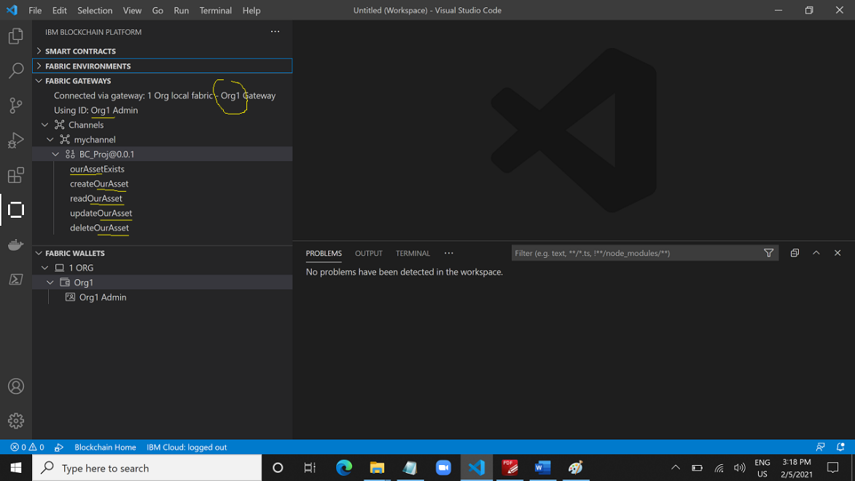

Although the 5 Methods appeared, but Create Transaction page did not appear at all. Rename in the json file BC_Proj to demo-contract the 1 error goes away.

Re-create the contract

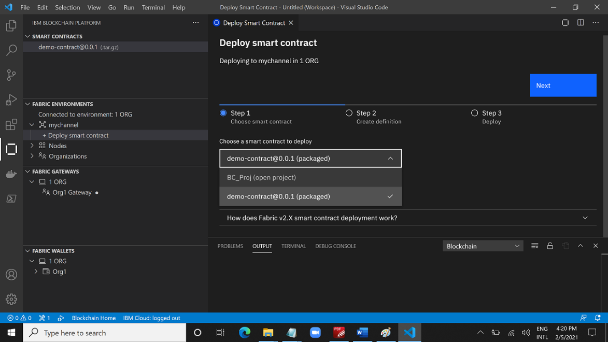



Above did not work either even though the 5 Methods appeared.

I teardown the fabric. Closed VS. Rename the folder to demo-contract. Reopen VS. Delete package Smart Contracts.

Re-do from A2.

OurAsset is still there. Hmmm…

* A3.
  + Connected to 1 ORG, FABRIC ENVIRONMENTS
  + Created demo-contract@0.0.1, SMART CONTRACTS
  + Deployed demo-contract@0.0.1, FABRIC ENVIRONMENTS
* A4.
  + Clicked 1 ORG Gateway, FABRIC GATEWAYS
  + Connected via gateway: 1 Org local fabric – Org1 Gateway

Again it did not work.

**2 Apr 2021, 1700hrs +++**

Re-do from A2. Deleted from D drive and insisting doing from D drive.

OurAsset instead MyAsset.

I hack care the why cannot see the Create Transaction page because nothing seems wrong and and proceed with A5. And finally, the truth is out.

This tutorial has pre-determined the directory “1 Org local fabric”, i.e. the environment MUST be called as “1 Org local fabric”. For this test I created the environment as theORG so there no 1 Org local fabric. The exporting the json file still looking for the directory, or environment name, to copy the json file. This is directory is C drive, user/…

This stupid tutorial should have said so!!!!!!!!!!!!!!!!!!!!!!!!!!!!!!!!!!!!!!!!!!!!!!!!!!!!!!!!!

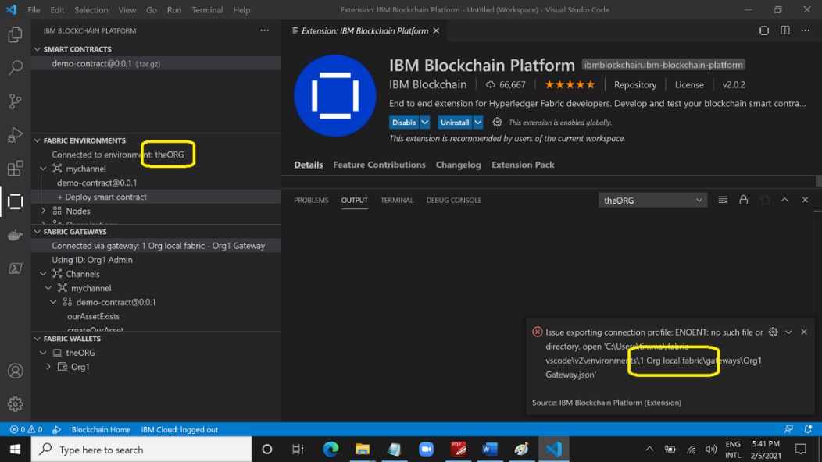

**3 Apr 2021, 0839hrs**

I suspect the IBM extension tie down is due to this setting. There is no sense that must called the environment “1 Org local fabric”.

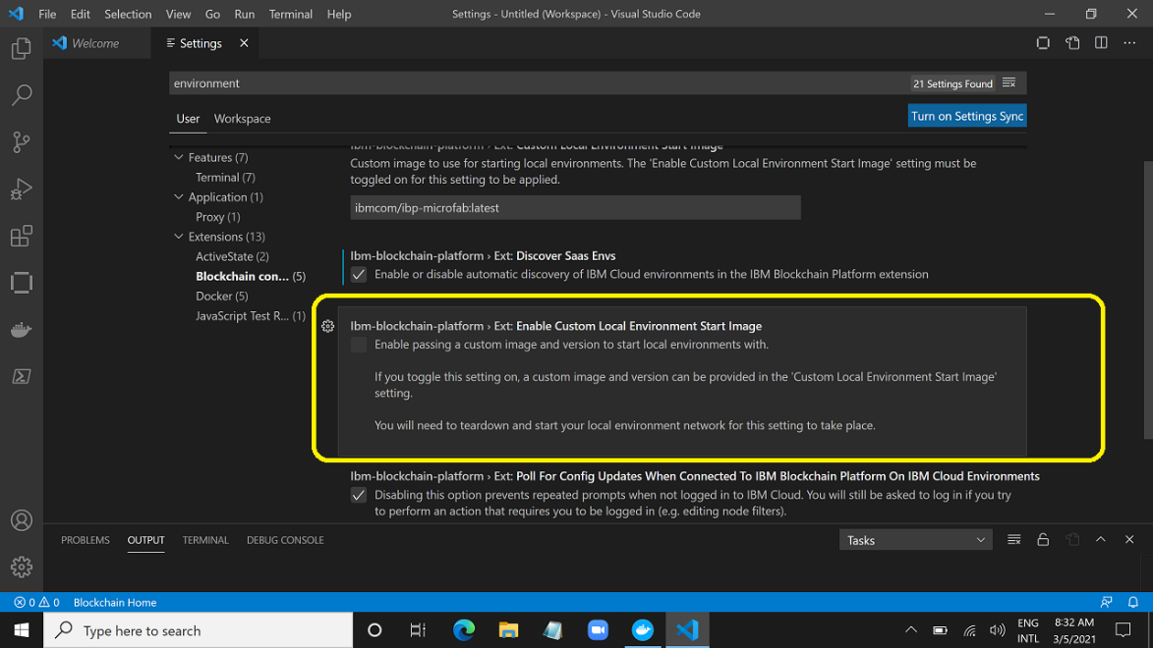

But not now to determine the

So re-do, following the settings.

Environment: 1 Org local fabric

Asset Name: OurAsset

Folder: D drive, demo-contract < D:\TKH\IBM_BC\demo-contract>

>>.> Just notice that the directory can only contain alphanumeric, “-” and “_” characters. This message was together when creating the folder.

* A2
  + Created smart contract project – demo-contract at < D:\TKH\IBM_BC\demo-contract>
* A3.
  + Connected to 1 Org local fabric, FABRIC ENVIRONMENTS
  + Created demo-contract@0.0.1, SMART CONTRACTS
  + Deployed demo-contract@0.0.1, FABRIC ENVIRONMENTS
* A4.
  + Clicked 1 Org local fabric Gateway, FABRIC GATEWAYS
  + Connected via gateway: 1 Org local fabric – Org1 Gateway

All 5 Methods appeared but it keeps saying run the command myself, Transaction View just will not appear.

So again

Environment: 1 Org local fabric

Asset Name: MyAsset

Folder: D drive, demo-contract < D:\TKH\IBM_BC\demo-contract>

All 5 Methods appeared but it keeps saying run the command myself, Transaction View just will not appear.

Nonetheless, I tested A5 to export and it worked obviously because I called the environment as 1 Org local fabric KNN…

I will return to DESKTOP folder demo-contract.

**3 Apr 2021, 1628hrs**

Desktop demo-contract all working fine except the TransactionPage did not appear. The same message by some idiot asking me to run command.

And after lunch, no idiot so no stupid message but still cannot open.

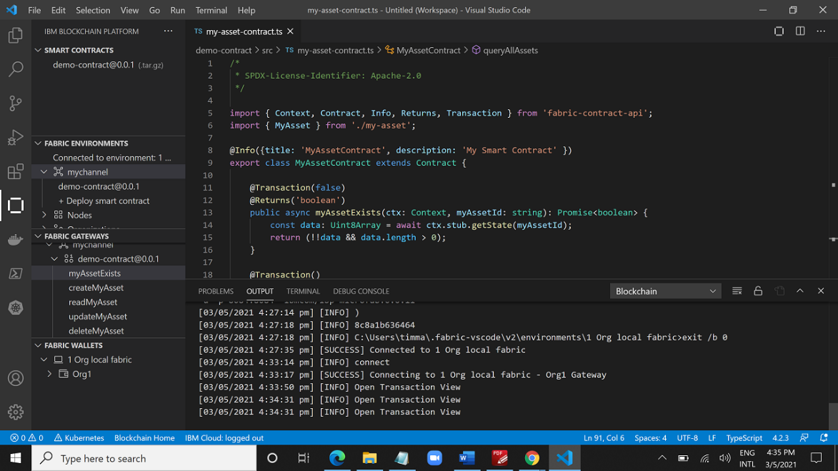

I have completed A6 regardless of the no show.

The completion of this tutorial A series are recorded in the PDF files.

**6 July 2021**: Again created 2 Org Local Fabric, twobytwo **to understand the wallets, identity configurations based on 2 Org Template by IBM**.

<<D:\TKH\1_Project\2_blockchain\twobytwo>>

Connected to 2 Org Local Fabric. Created the package but **has not deployed** **the contract** and **has not connected to any gateway**. This is what it looks like, taking note of the settings of each component.

|  |  |  |  |
| --- | --- | --- | --- |
|  |  |  |  |
| Full view of after connecting to 2 Org Local Fabric.  *Ignore 1 OLF.* | Peer has MSPID, which CA does not show or have… | Orderer also has MSPID, just like a Peer. | CA requires its own admin |
|  | |  | |
| Organization, only showing this detail. Same for Org1 and Org2 | | This shows the wallet. | |
|  | |  | |
| Inside 2 Org Local Gateway: there are **2 gateways** for Org1 and Org2.  Org1 has its **own Wallet**, and so is **Org2**.  Ignore the red arrow and it is tested - not related to 1 Org Local Fabric (*created from 1 Org Template in earlier tutorial*) | | | |
|  | |  | |
| **Above showed after connected to gateway Org1 Gateway and Org2 Gateway sequentially.**  Inside VS Code, at one time you can only connected to one gateway, because you cannot be playing two organizations at the same time during development.  On LHS, it is **connected to Org1 Gateway**. And it stated using **IDENTITY Org1 Admin (which is Org1 Peer)**, the notes also stated why so. Of course if you have more than one peer identities in your organization’s wallet you can hence choose which to use.  In the 2 Org Template, IBM preloaded only one peer for each organization. | | | |

These are the Output on Blockchain (dropdown list) the moment I clicked on Click to Start under Fabric Environments.

|  |
| --- |
| [06/07/2021 5:51:20 pm] [INFO] connecting to fabric environment  [06/07/2021 5:51:21 pm] [INFO] startFabricRuntime  [06/07/2021 5:51:21 pm] [INFO] C:\Users\timma\.fabric-vscode\v2\environments\2 Org Local Fabric>  [06/07/2021 5:51:21 pm] [INFO] rem  [06/07/2021 5:51:21 pm] [INFO] C:\Users\timma\.fabric-vscode\v2\environments\2 Org Local Fabric>rem Copyright IBM Corp All Rights Reserved  [06/07/2021 5:51:21 pm] [INFO] C:\Users\timma\.fabric-vscode\v2\environments\2 Org Local Fabric>rem  [06/07/2021 5:51:21 pm] [INFO] C:\Users\timma\.fabric-vscode\v2\environments\2 Org Local Fabric>rem SPDX-License-Identifier: Apache-2.0  [06/07/2021 5:51:21 pm] [INFO] C:\Users\timma\.fabric-vscode\v2\environments\2 Org Local Fabric>rem  [06/07/2021 5:51:21 pm] [INFO] C:\Users\timma\.fabric-vscode\v2\environments\2 Org Local Fabric>setlocal enabledelayedexpansion  [06/07/2021 5:51:21 pm] [INFO] C:\Users\timma\.fabric-vscode\v2\environments\2 Org Local Fabric>SET CUSTOM_IMAGE=  [06/07/2021 5:51:21 pm] [INFO] C:\Users\timma\.fabric-vscode\v2\environments\2 Org Local Fabric>if DEFINED CUSTOM_IMAGE (SET START_IMAGE= ) ELSE (SET  [06/07/2021 5:51:21 pm] [INFO] START_IMAGE="ibmcom/ibp-microfab:0.0.11" )  [06/07/2021 5:51:21 pm] [INFO] C:\Users\timma\.fabric-vscode\v2\environments\2 Org Local Fabric>echo "Using image: "ibmcom/ibp-microfab:0.0.11""  [06/07/2021 5:51:21 pm] [INFO] "Using image: "ibmcom/ibp-microfab:0.0.11""  [06/07/2021 5:51:21 pm] [INFO] C:\Users\timma\.fabric-vscode\v2\environments\2 Org Local Fabric>FOR /F "usebackq tokens=*" %g IN (`docker ps -f label=fabric-environment-name="2 Org Local Fabric Microfab" -q -a`) do  [06/07/2021 5:51:21 pm] [INFO] (SET CONTAINER=%g )  [06/07/2021 5:51:22 pm] [INFO] C:\Users\timma\.fabric-vscode\v2\environments\2 Org Local Fabric>(SET CONTAINER=ab90ac51391a )  [06/07/2021 5:51:22 pm] [INFO] C:\Users\timma\.fabric-vscode\v2\environments\2 Org Local Fabric>IF DEFINED CONTAINER (  [06/07/2021 5:51:22 pm] [INFO] docker start ab90ac51391a  [06/07/2021 5:51:22 pm] [INFO] if !errorlevel! NEQ 0 (exit /b !errorlevel! )  [06/07/2021 5:51:22 pm] [INFO] ) ELSE (  [06/07/2021 5:51:22 pm] [INFO] SET MICROFAB_CONFIG={"port":8086, "endorsing_organizations": [{"name": "Org1"},{"name": "Org2"}],"channels": [{"name": "mychannel","endorsing_organizations": ["Org1", "Org2"]}]}  [06/07/2021 5:51:22 pm] [INFO] docker run -e MICROFAB_CONFIG --label fabric-environment-name="2 Org Local Fabric Microfab" -d -p 8086:8086 "ibmcom/ibp-microfab:0.0.11"  [06/07/2021 5:51:22 pm] [INFO] )  [06/07/2021 5:51:26 pm] [INFO] ab90ac51391a  [06/07/2021 5:51:26 pm] [INFO] C:\Users\timma\.fabric-vscode\v2\environments\2 Org Local Fabric>exit /b 0  [06/07/2021 5:51:38 pm] [SUCCESS] Connected to 2 Org Local Fabric |

When I clicked Package Smart Contract, these are the output.

|  |
| --- |
| [06/07/2021 6:10:34 pm] [SUCCESS] Smart Contract packaged: C:\Users\timma\.fabric-vscode\v2\packages\twobytwo@0.0.1.tar.gz  [06/07/2021 6:10:34 pm] [INFO] 16 file(s) packaged:  [06/07/2021 6:10:34 pm] [INFO] - metadata.json  [06/07/2021 6:10:34 pm] [INFO] - src/dist/index.d.ts  [06/07/2021 6:10:34 pm] [INFO] - src/dist/index.js  [06/07/2021 6:10:34 pm] [INFO] - src/dist/index.js.map  [06/07/2021 6:10:34 pm] [INFO] - src/dist/mytwobywo-asset-contract.d.ts  [06/07/2021 6:10:34 pm] [INFO] - src/dist/mytwobywo-asset-contract.js  [06/07/2021 6:10:34 pm] [INFO] - src/dist/mytwobywo-asset-contract.js.map  [06/07/2021 6:10:34 pm] [INFO] - src/dist/mytwobywo-asset.d.ts  [06/07/2021 6:10:34 pm] [INFO] - src/dist/mytwobywo-asset.js  [06/07/2021 6:10:34 pm] [INFO] - src/dist/mytwobywo-asset.js.map  [06/07/2021 6:10:34 pm] [INFO] - src/package.json  [06/07/2021 6:10:34 pm] [INFO] - src/src/index.ts  [06/07/2021 6:10:34 pm] [INFO] - src/src/mytwobywo-asset-contract.spec.ts  [06/07/2021 6:10:34 pm] [INFO] - src/src/mytwobywo-asset-contract.ts  [06/07/2021 6:10:34 pm] [INFO] - src/src/mytwobywo-asset.ts  [06/07/2021 6:10:34 pm] [INFO] - src/transaction_data/mytwobywo-asset-transactions.txdata |

And terminal showed these.

|  |
| --- |
| > Executing task in folder twobytwo: npm run build <  > twobytwo@0.0.1 build D:\TKH\1_Project\2_blockchain\twobytwo  > tsc |

This then followed by A3.8 steps.

Inside the main page for Deploy Smart Contract, there is a write up.

|  |
| --- |
| How does Fabric v2.X smart contract deployment work?  This deployment flow simplifies the steps below and you will only need to know these steps if you intend on using the operator console to operate a Blockchain network. If you do wish to operate a network in the future, or just want to know about how the smart contract deployment works in Fabric v2.0, then continue reading.  **Step 1**  **Your smart contract is packaged**  We need to package the chaincode before it can be installed on our peers.  **Step 2**  **Each of the network's member organizations install the package on their peers**  After we package the smart contract, we can install the chaincode on our peers. The chaincode needs to be installed on every peer that will endorse a transaction.  **Step 3**  **Each organization approves a shared definition of what they will use on the channel**  After you install the chaincode package, you need to approve a chaincode definition for your organisation. The definition includes important parameters of chaincode governance such as the name, version, and the chaincode endorsement policy.  **Step 4**  **The definition is then committed: a transaction endorsed by the channel members**  After a sufficient number of organizations have approved a chaincode definition, one organization can commit the chaincode definition to the channel. If a majority of channel members have approved the definition, the commit transaction will be successful and the parameters agreed to in the chaincode definition will be implemented on the channel.  -----------------  There is a link to the above extracts from VS Code.  <https://hyperledger-fabric.readthedocs.io/en/release-2.0/chaincode_lifecycle.html>  Within it, "More information You can watch video below to learn more about the motivation of the new Fabric chaincode lifecycle and how it is implemented." There links to a YouTube: <https://www.youtube.com/watch?v=XvEMDScFU2M> |

Contract successfully deployed and completed A3 with 2 Org Template.

**Name** and **Value** created for 1 Org: 1Org001 🡪 1Org001

**Name** and **Value** created for 2 Org: 2Org001 🡪 2Org001